University Of Engineering and Technology, Lahore Computer Engineering Department

Course Name: PF | Course Code: CMPE-112L
Assignment Type: Lab | Dated: 25 may 2026
Semester: 1st | Session: Spring 2026
Lab/Project/Assignment #: 13 | CLOs to be covered: CLO2
Lab Title: MAP, Filter and Reduce | Teacher Name: Hafiz Muhammad Mubashar

Lab Evaluation:

CLO1 | Apply appropriate programming techniques to create executable programs to solve well defined problems
 | Level1 | Level2 | Level3 | Level4 | Level5 | Level6
(5)
Total |  |  |  |  |  | /5

Rubrics for Current Lab Evaluation

Scale | Marks | Level | Rubric
Excellent | 5 | L1 | Submitted all lab tasks, BONUS task, have good understanding.
Very Good | 4 | L2 | Submitted the lab tasks but have good understanding
Good | 3 | L3 | Submitted the lab tasks but have weak understanding.
Basic | 2 | L4 | Submitted the lab tasks but have no understanding.
Barely Acceptable | 1 | L5 | Submitted only one lab task.
Not Acceptable | 0 | L6 | Did not attempt

LAB No 13
Lab Goals/Objectives:
- To understand functional programming concepts.
- To use map(), filter(), and reduce().
- To process collections efficiently.
- To combine lambda functions with built-in functions

Equipment Required:
- Computer/Laptop
- Python
- Visual Studio Code / PyCharm / IDLE
Theory:
Python provides built-in functions such as map(), filter(), and reduce() for processing collections of data. The map() function applies a specified function to every item in an iterable, while filter() selects only those elements that satisfy a given condition. The reduce() function, available in the functools module, combines all elements into a single result. These functions simplify data processing and promote efficient programming.

Lab Work:

Task 1:

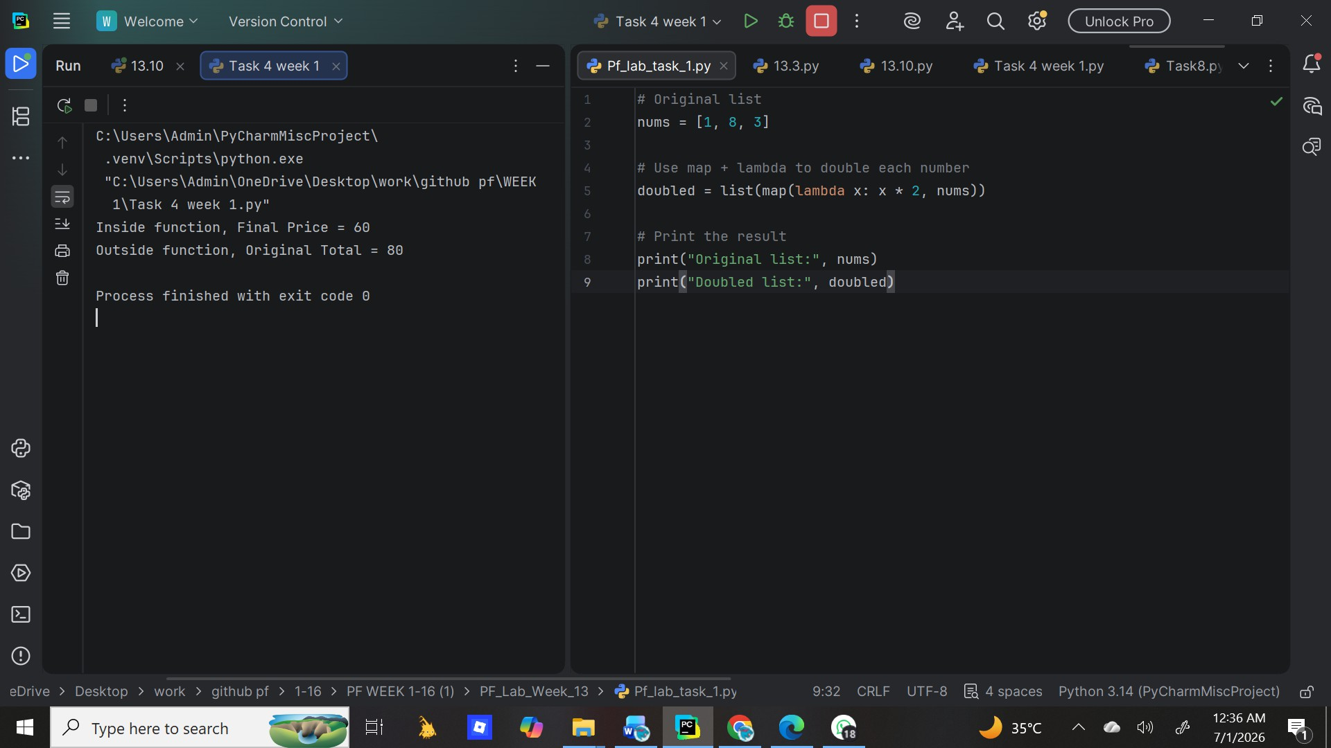
Result:

Write a Python program using `map` and a `lambda` function to double each number in the list `[1, 8, 3]` and print the result.

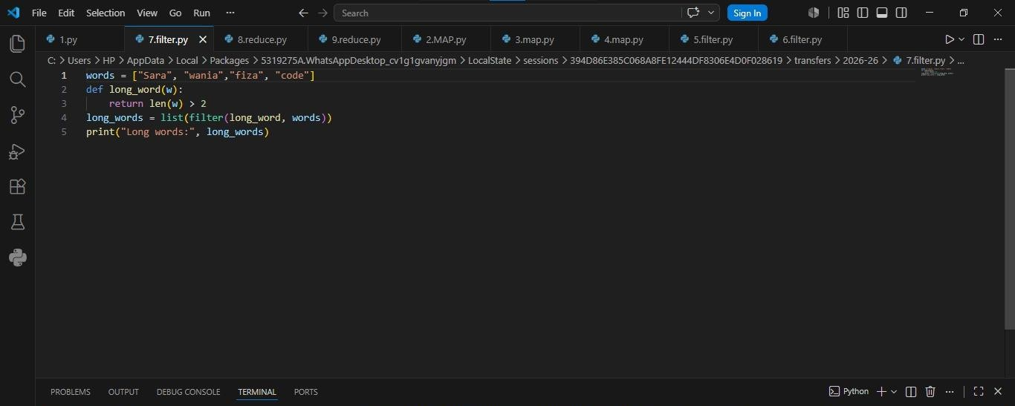

Task 2:
Write a Python program that defines a list `words , creates a `long_word(w)` function that returns `True` if `len(w) > 2`, uses `filter` with that function to get
all long words, and prints `Long words:` followed by the result.
Result:

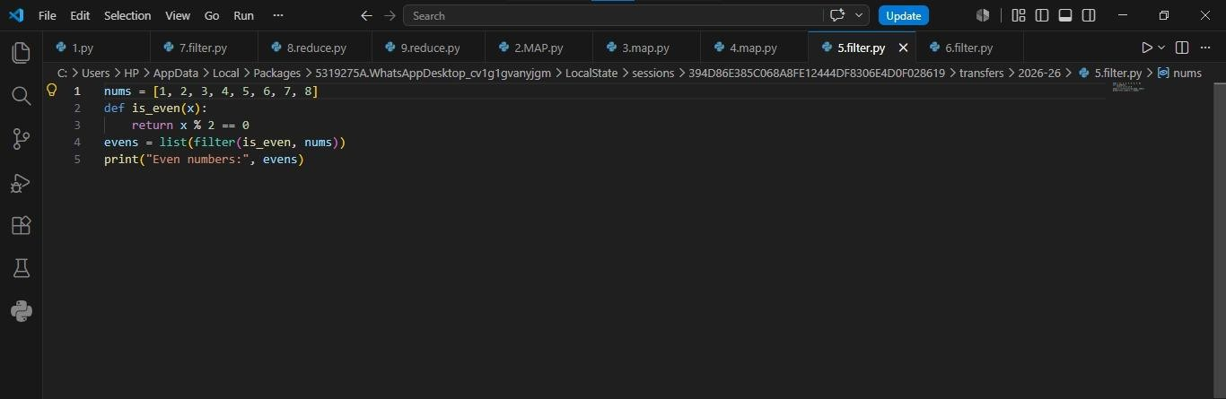

Task 3:
Write a Python program that defines an `is_even(x)` function returning `True` if `x % 2 == 0`, uses
`filter` with that function on a list, and prints `Even numbers:` followed by the result.
Result:

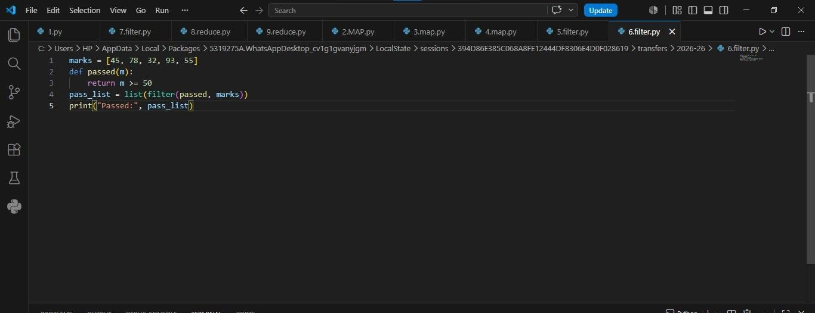

Task 4:
Write a Python program that defines a `passed(m)` function returning `True` if `m >= 50`, uses `filter` with that function on a list and prints `Passed:` followed by the result.
Result:

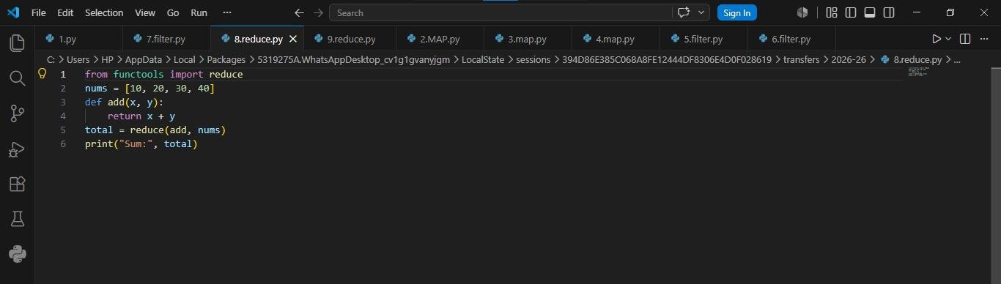

Task 5:
Write a Python program that imports `reduce` from `functools`, defines an `add(x, y)` function that returns `x + y`, uses `reduce` with that function on a list and prints `Sum:` followed by the result. Result:

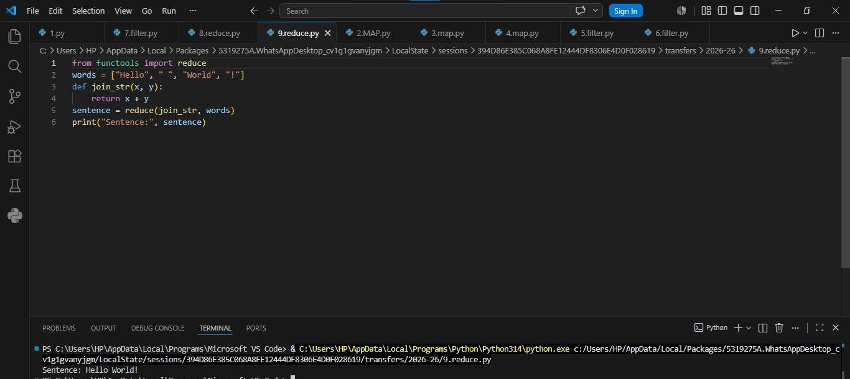

Task 6:
Write a Python program that imports `reduce` from `functools`, defines a `join_str(x, y)` function that returns `x + y`, uses `reduce` with that function on a list `["Hello", " ", "World", "!"]`, and prints `Sentence:` followed by the result.

Result:

Task 8:
Write a Python program that defines a `capitalize(name)` function returning `name.title()`, uses `map` with that function on a list converts the result to a list, and prints `Names:` followed by the result.
Result:
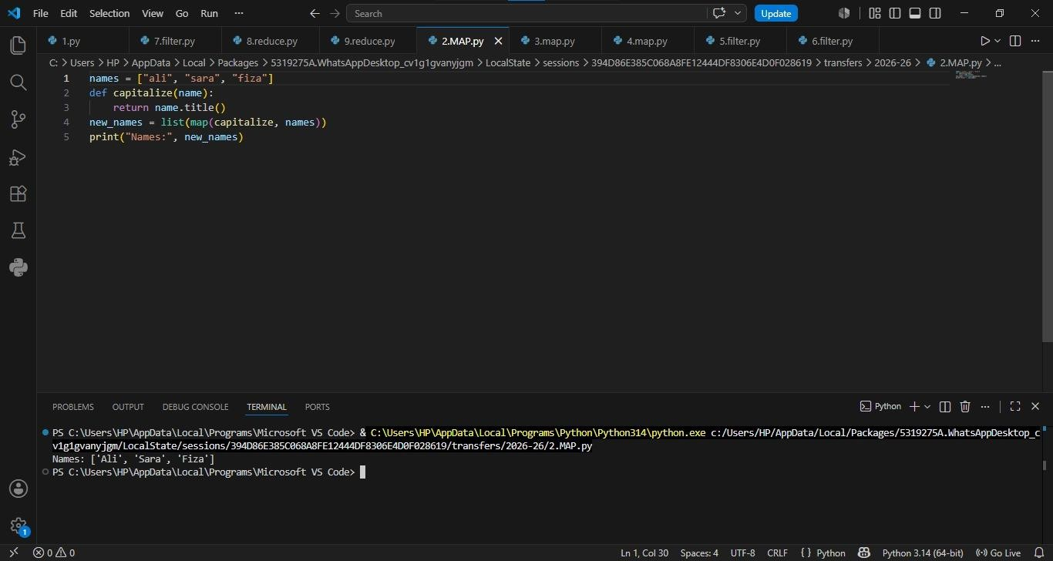

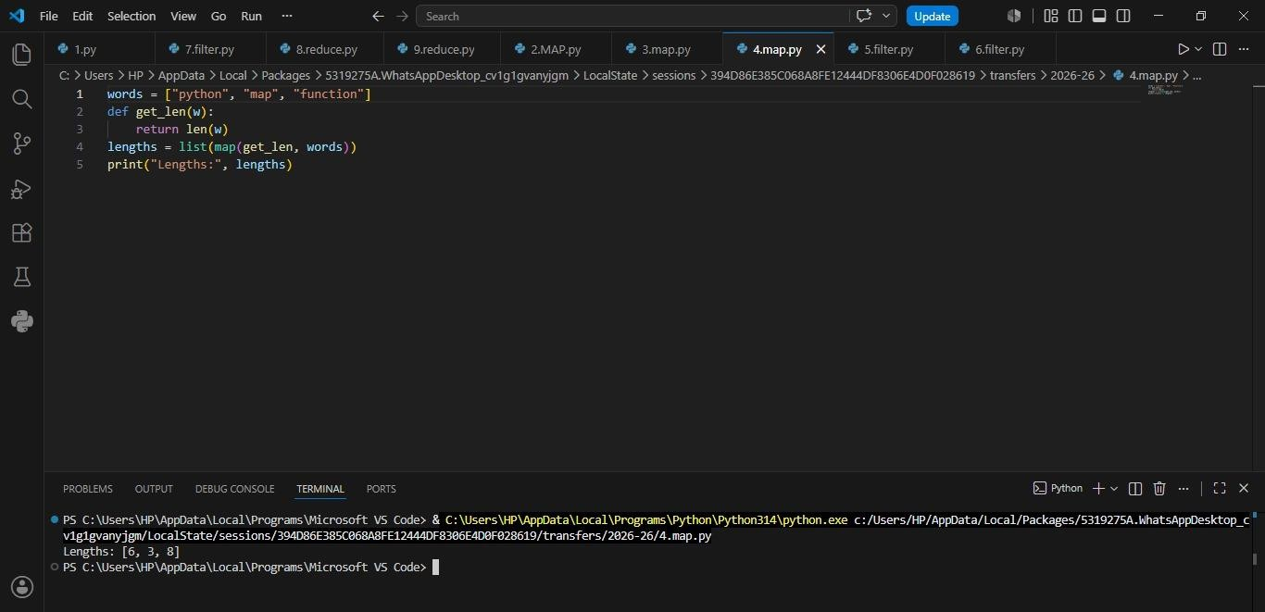
Task 9:
Write a Python program that defines a `calc(x)` function returning `x**2 + 11`, uses `map` with that function on a list, converts the result to a list, and prints `Result:` followed by the result.
Result:
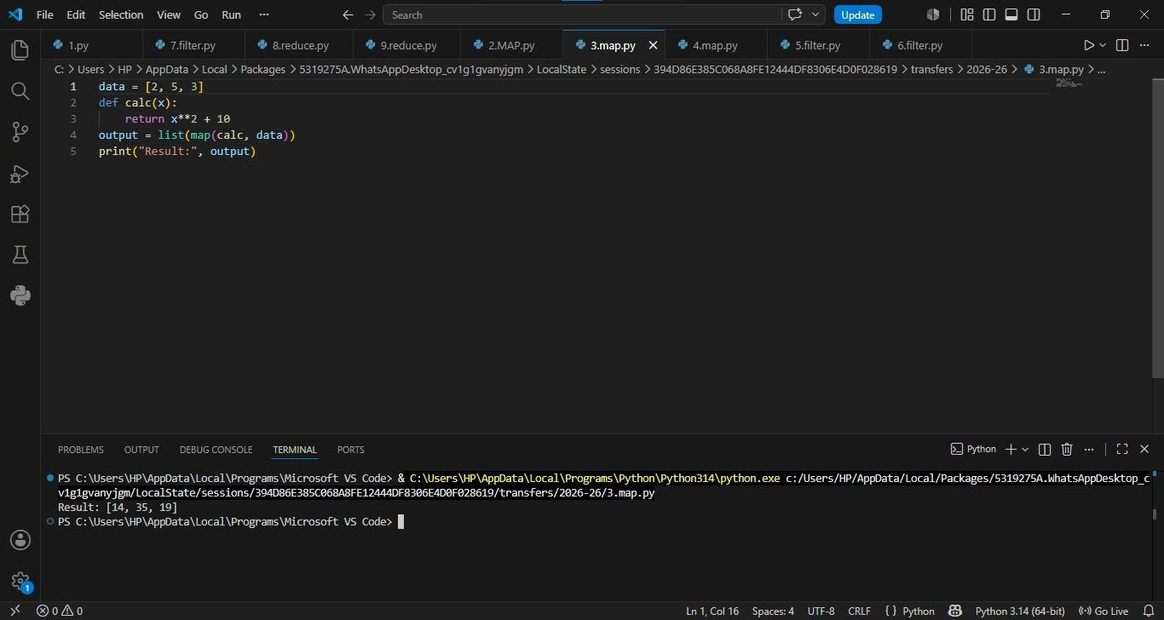
Task 10:
Write a Python program that defines a `get_len(w)` function returning `len(w)`, uses `map` with that function on a list `["python", "map", "function"]`, converts the result to a list, and prints
`Lengths:` followed by the result.

Result:

Conclusion
MAP = For transformation. Use when you need to change every item.

Ex: Convert prices to dollars, uppercase all namesFILTER = For selection. Use when you need a subset based on condition.

Ex: Get passing students, get products > 1000rsREDUCE = For aggregation. Use when you need 1 final result from all items.

Ex: Sum, Product, Max, Min

